
 |  |  | 
 |  |  | 

Eforest
Interpolation Service Architecture

“Framework contract for the provision of forest data and services in support to the European Forest Data Centre”
Reference: 2007/ S 194-235358 of 09/10/2007

Contents

1 Introduction 3
2 Logical Architecture 4
3 Algorithms 5
3.1 Inverse distance weighted 5
4 Annexes 5
4.1 R Process execution 5

Introduction

The goal of the interpolation service is to provide the possibility to generate a smoothed cartographic layer that can be displayed as a map from the raw data.

This module should allow the user to select an interpolation method (currently only IDW is available) with some parameters in order to generate a map.

The interpolation method is implemented as a R script.

It was foreseen to use the INTAMAP project in order to benefit from automatic outliers detection and other functionalities. But due to the large volume of data and performance problems when integrating R and java, we have used a different solution.

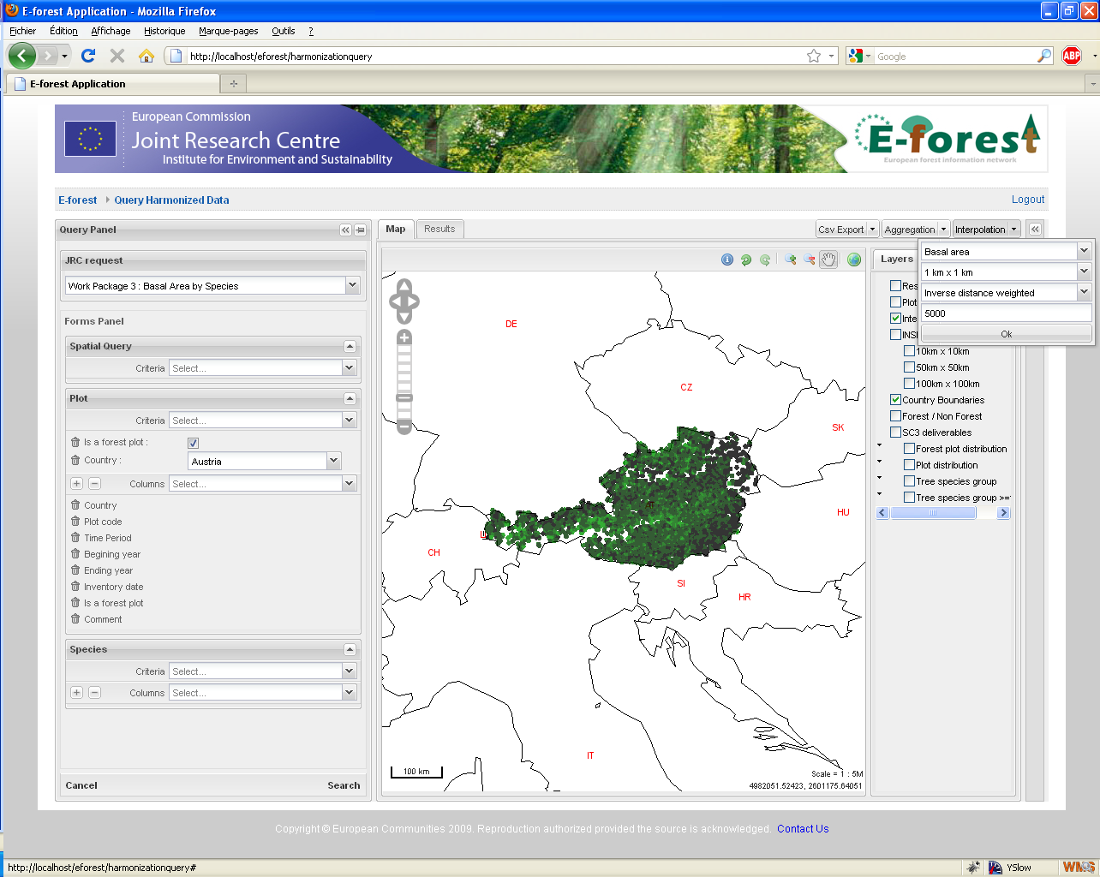

Logical Architecture

PHP
Web Site
Browser
JAVA
Interpolation Service

RAW_DATA
CSV File

Extracted data
R Script
R
ESRI asciigrid
Mapserver
Value +
SQL filter

On the web interface, the user select a list of plot values to interpolate, then he chose an interpolation method and some interpolation parameters.

When the interpolation service is called :
- We extract from the database the list of plot coordinates and values to be interpolated (using the SQL query filter given by the PHP part) and we store it in a CSV file identified with the user session id.
- We generate a R script corresponding to the selected parameters and the generated datafile.
- Then we launch the R engine on the R script. The resulting data file is generate in the ESRI asciigrid format that can be read by mapserver.

One layer “interpolation_result” is predefined and is hidden by default. It is made available when the interpolation result is ready. The layer takes the user session id as a parameter and uses it to locate the result data file.

Algorithms

Inverse distance weighted

R Script :
library(gstat)

# Read the data file
gtot <-read.table("c:/temp/gtot.csv", header = T, sep=";")

# Generate a grid surrounding the plots to interpolate
A <- seq(round(min(gtot$X)/1000)*1000, round(max(gtot$X)/1000)*1000, by=1000)
B <- seq(round(min(gtot$Y)/1000)*1000, round(max(gtot$Y)/1000)*1000, by=1000)
a <- rep(A, length(B))
b <- rep(B, length(A))
b <- sort(b, decreasing=F)
grid <- data.frame(x=a, y=b)

# Give some spatial coordinates to the gtot object
coordinates(gtot) = ~X + Y

# Give a topology to the grid object
gridded(grid) = ~x+y

# Calculate the IDW of the variable
gtot_idw <- idw( (GTOT)~1 , gtot, grid, maxdist = 5000)

# Save the result in a ESRI asciigrid file
write.asciigrid(gtot_idw, "c:/temp/idw_gtot.asc", attr = 1, na.value = -9999)

Annexes

R Process execution

The rJava java to R bridge have been tested but was having some problems of memory limit and of reusability.

In order to allow R to run with the maximum of available memory, we launch it thru an external shell.

To launch a shell in java in a consistent way (in Windows and FreeBSD) and in order to be able to read the result that is generated on the standard output, a small utility class “ExecLauncher” have been developed using the recommendations of a JavaWorld article.

